Rapid International Ltd Provide Mixing Solution for Roller Compacted Concrete in Mexico

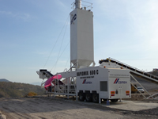Rapid International Ltd, has provided CEMEX with a solution for mixing vast amounts of Roller Compacted Concrete (RCC) at a dam which they are building close to Uruapan, Mexico. This solution comes in the form of their newest mobile unit, the Rapidmix 600 C, which allows them to mix up to 600 tons of concrete per hour.
CEMEX, one of the world’s leading concrete suppliers, is increasingly utilizing this cost effective and durable concrete which is also becoming more common in the construction of dams and paving in recent years.
RCC has the same properties as conventional concrete: cement; water; and aggregates. However, it is a drier mix and is compacted by vibratory rollers. It has the strength and performance of regular concrete yet it is as economical and as simple to use as asphalt.
Becoming more popular in the UK due to its cost-effective and durable benefits, RCC is being used for, ports, bulk material storage, car parks and access roads. Labor costs are cut as the method of construction is a lot quicker and it requires no forms, finishing or surface texturing.
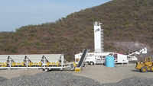At the Mexican dam, using the plant’s efficient hydraulic system, the Rapidmix 600 C was easily transformed from travel mode to a fully operational plant within hours.
The continuous mobile plant is capable of mixing up to 600 tons of concrete per hour. This is achieved through the mixing plant’s adjustable feed rates for the aggregate, cement and water systems. The control panel on the Rapidmix 600 C incorporates the most up-to-date technology, allowing the operator to store, edit and retrieve up to 30 recipes for the proportioning of different materials.
Once the mixing is complete through the in-built, twin shaft pugmill mixer, it is transported by the outloading conveyor onto a conveyor system which delivers the material to the dam. Material is then leveled and rolled.
Compaction begins immediately after placement which is how the concrete attains its level of smoothness, density, surface texture and strength. This stage continues until the density requirements are met. The final stage is curing where moisture is applied, allowing hydration of the concrete, thus causing it to harden and strengthen.
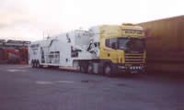The Rapidmix 600 C is suitable for many different projects including, environmental soil contamination applications, soil stabilization, mine back fill, bentonite land fill sealing, and road sub base. The Rapidmix has also been used in numerous mixing applications in the United States and Canada.
The Rapid International design team is constantly engaged in research and development work to improve and extend the company’s diverse range of products including Planetary Mixers, Pan Mixers and the Rapid Jetwash System. They pride themselves on their Pan and Planetary Mixer range, constantly striving to develop and improve these standard products.

